Actuarial Science Club Newsletter

Fourth Issue – May 2009
Hi everyone,
In the last newsletter, I know I said that there wouldn’t be another newsletter until spring, but we thought it would be a good idea to congratulate seniors who graduated as Marshals, from Schreyer’s, and/or With Distinction. I think I speak on behalf of the entire Actuarial Science Program when I say we are so proud of you! Congratulations! A message for students not graduating: Included at the end of this newsletter there is a brief survey; if that survey pertains to you please fill it out. The ActSci Club really appreciates your feedback.

Marshals
Marshals are the top graduates in their respective departments:
Mathematics Department: David Lytle
Statistics Department: Brett Lissenden
Actuarial Science: Chris Iannuzzi
*Henry Neeb got the College of Science Marshal honor last December.

Schreyer
The following students graduated from the Honors College: Zhao Lang, Brett Lissenden, Marlee Mengel, Jennifer Ober, Andrew Timcheck, and Jeff Schultz

Sapphire
The following students graduated from Smeal’s Sapphire Program: Diana Gross, Chris Iannuzzi

The top 12% of baccalaureate degree candidates from any college graduate With Distinction. That 12% is divided into “With Highest Distinction” (top 2%), “With High Distinction” (4%), and “With Distinction” (6%).

With Highest Distinction
The following students graduated With Highest Distinction: Vinny DelPrince, Matt Fishel, Chris Iannuzzi, David Lytle, Marlee Mengel, and Henry Neeb

With High Distinction
The following students graduated with High Distinction: Mindy Chmielewski, Brett Lissenden, Jennifer Ober, Jeff Schultz, and Lori Ann Shero

With Distinction
The following students graduated With Distinction: Ryan Beberus, Jennifer Edwards, Lindsay Rau, Steve Regester, Lisa Schmidt, and Dzuhailah Yusoff

Congratulations Graduates!
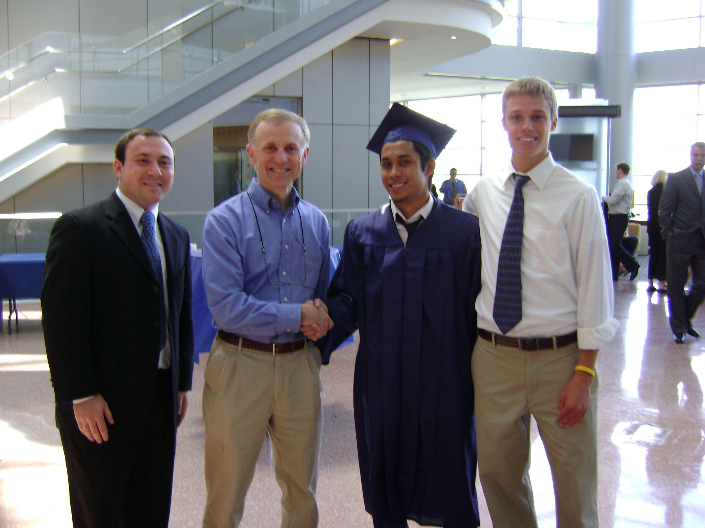
Chris Iannuzzi, Ron, Ajmal Jamal, and Ryan Beberus
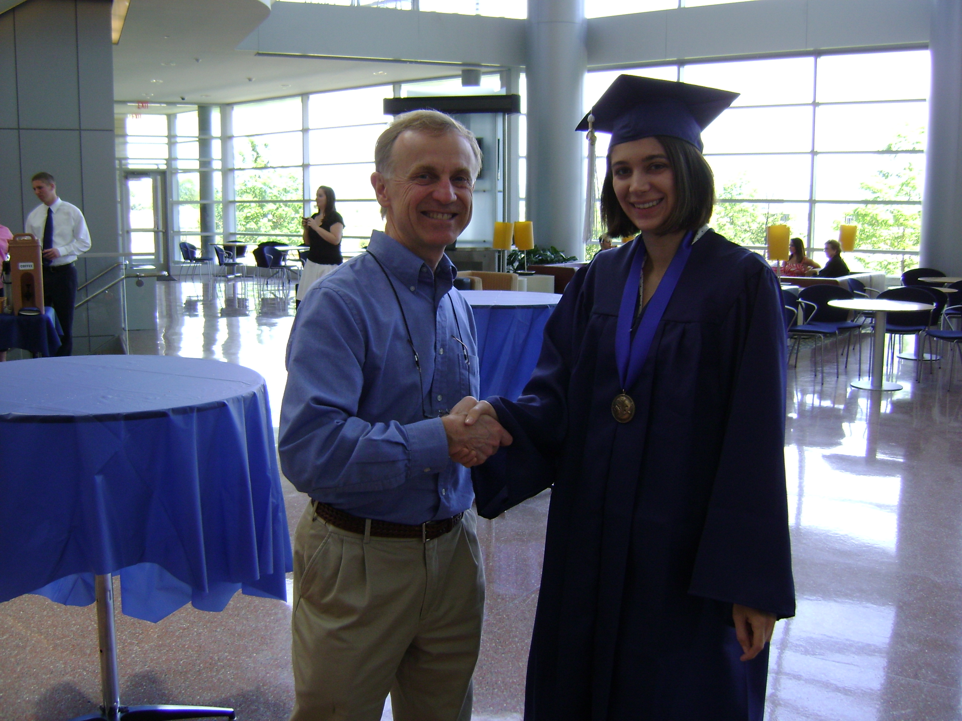
Ron and Marlee Mengel
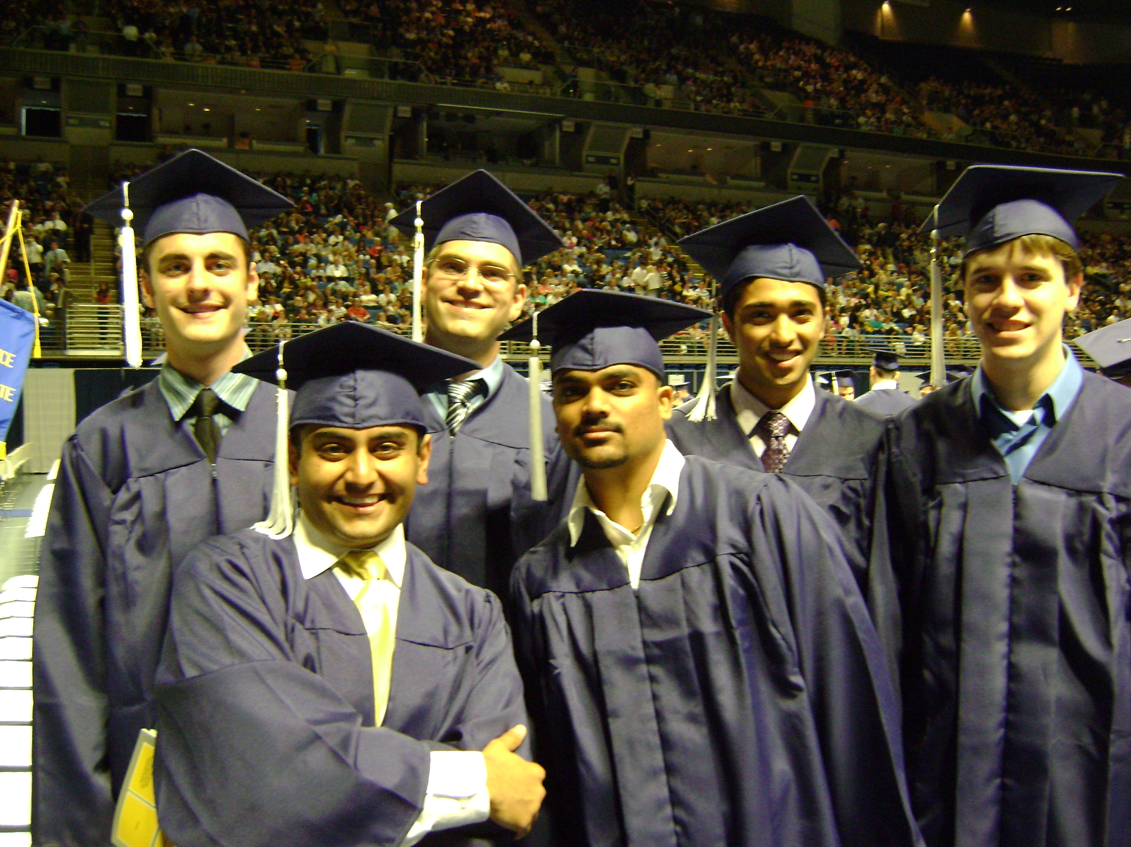
Bhargav Modi, Krunal Desai in front and Ryan Trott, Matt Fishel, Anil Nisar, and Sean Brownlee in back
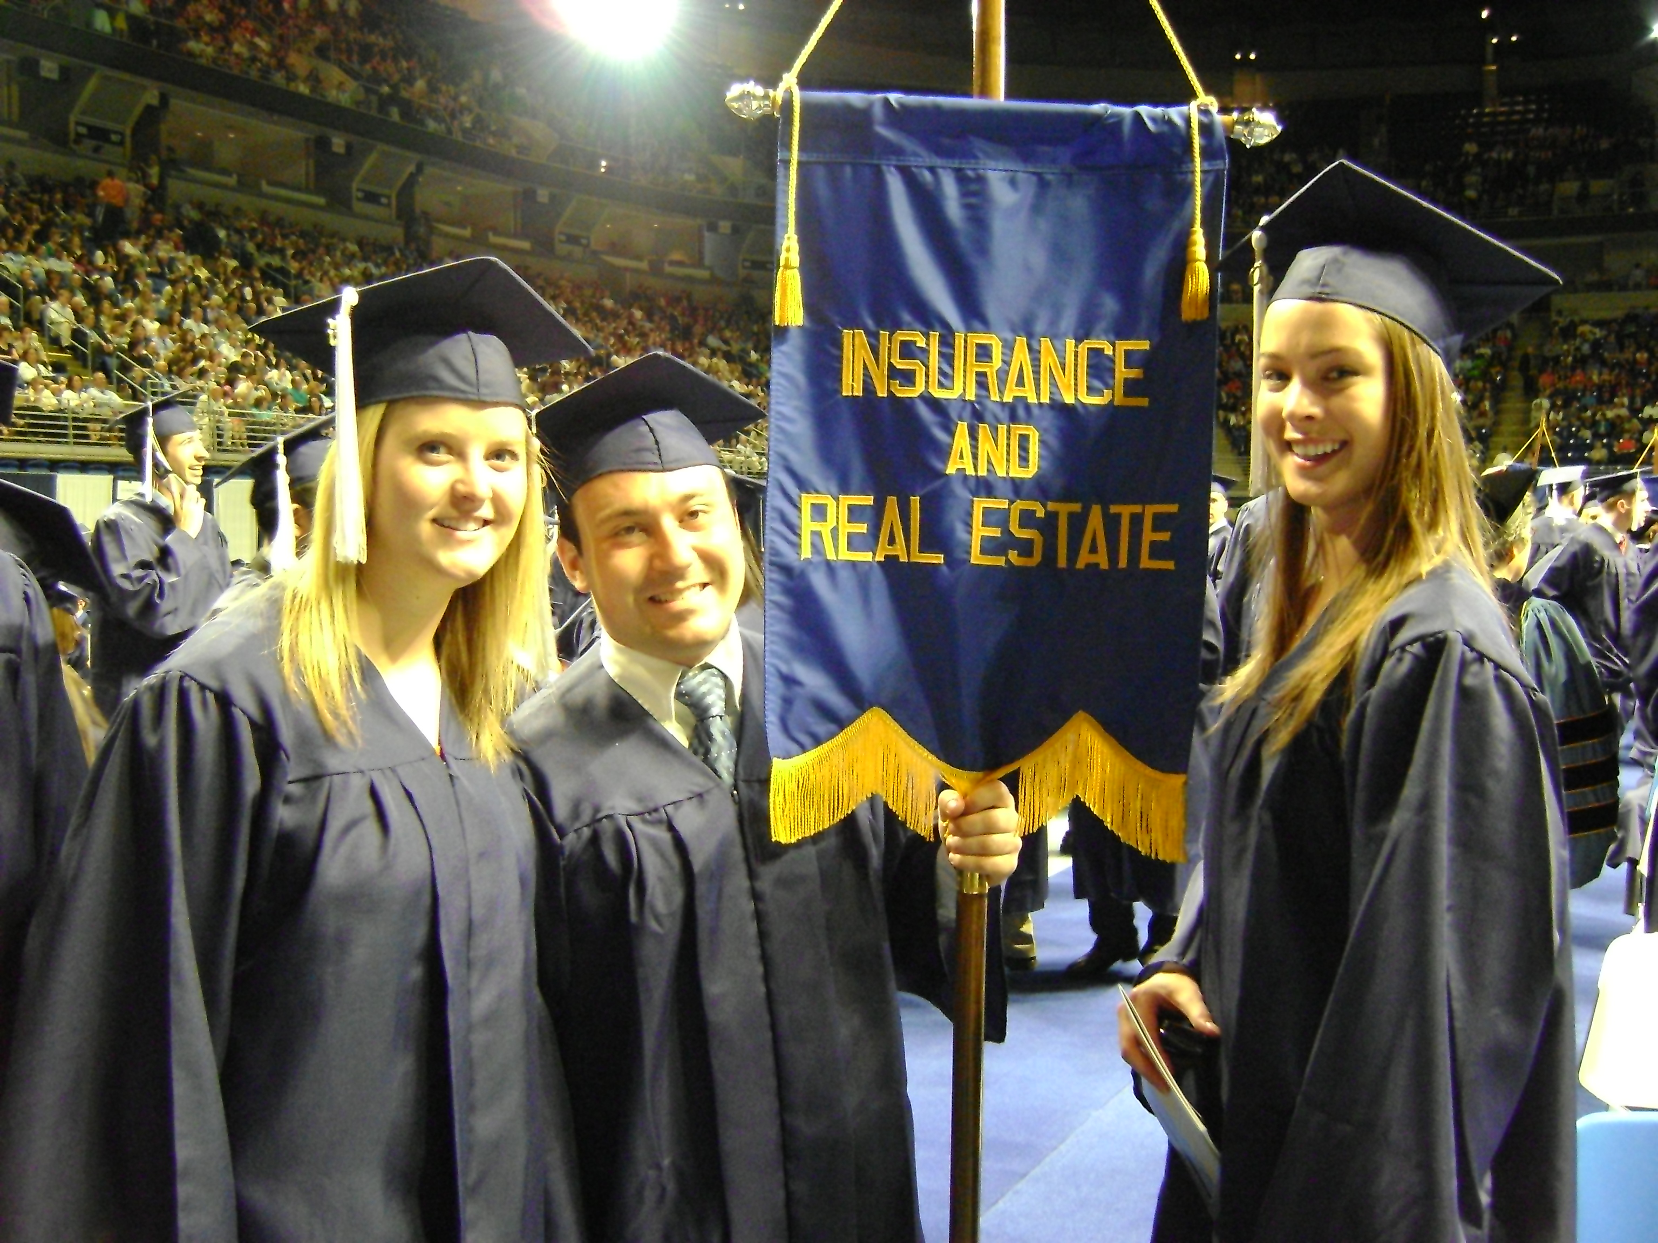
Diana Gross, Chris Iannuizzi, and Amanda Rearick
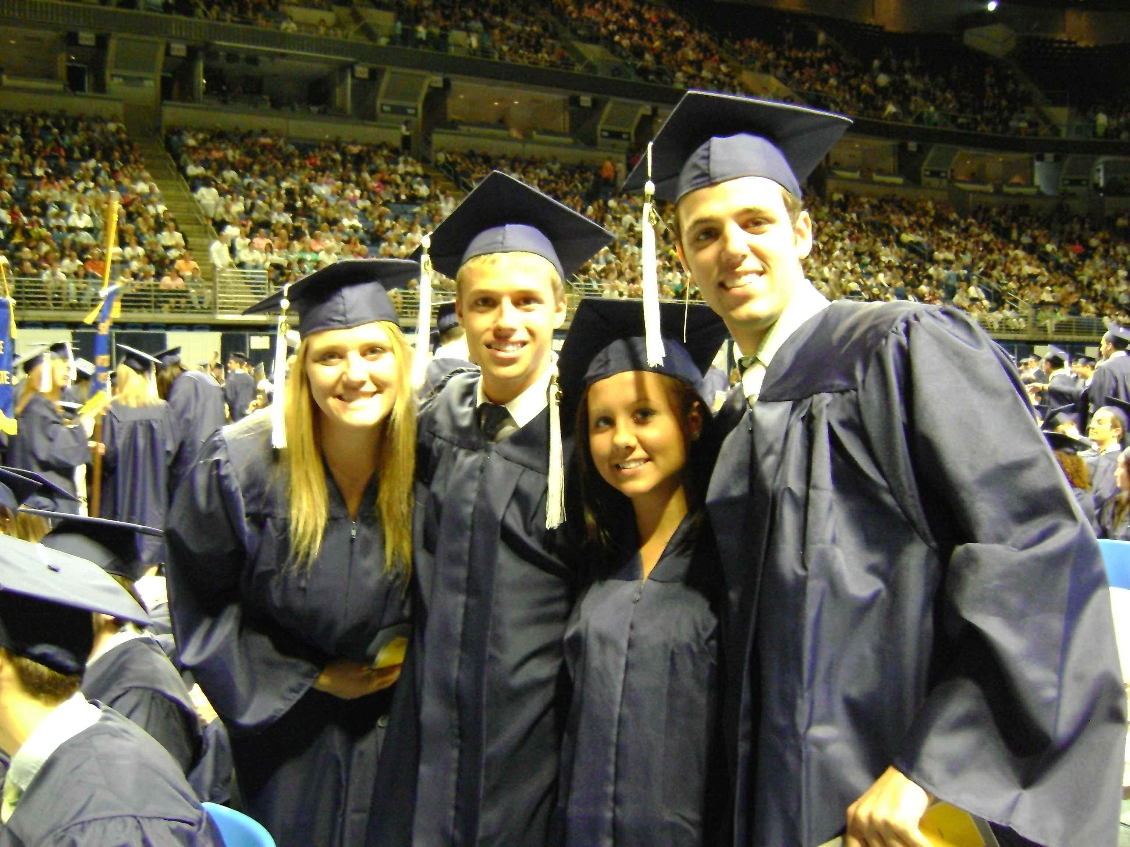
Mindy Chmielewski, Ryan Beberus, Mercedes Miske, & George Heigel

Exam Passers
Many people have passed exams since the last newsletter was sent out, so the list has been updated. Congrats to those who have recently passed exams!

Exam P Exam FM
Sean Brownlee Damir Amonov
Michael Fairchild Sean Brownlee
Samantha Clayton Melinda Chmielewski
Vincent Delprince Matt Fishel
Jennifer Edwards Allen Gonczol
Matt Radlow Christopher Iannuzzi
Allen Gonczol Zhao Lang
Christopher Iannuzzi Brett Lissenden
Zhao Lang David Lytle
Brett Lissenden Kyle MacWade
David Lytle Vincent McGinnis
Kyle MacWade Marlee Mengel
Sarah Mathers Henry Need
Marlee Mengel Jennifer Ober
Bhargav Modi Jungbin Park
Henry Need Lindsay Rau
Jennifer Ober Alyson Schefkind
Jungbin Park Andrew Timcheck
Raul Patel Ryan Trott Benjamen Propst Brianna Zambito
Lindsay Rau Andrew Parr
Steven Regester Sung Oh
Ryan Roebuck Eric Giangiulio
Lisa Schmidt Amanda Rearick
Pamela Schrier Brett Warren
Jeffrey Schultz Mike Gallagher
David Solomon Fan Xie
Andrew Timcheck Robert Antochy
Josh Yorke Ryan Roebuck
Brett Warren Eric Giangiulio
Tom Novak Brennan Kohrherr
Sung Oh Matt Modzelewski
Melanie Smith Jennifer Edwards
Jeff Conway
Paul Andrejko
Robert Antochy
Ying-Hui Huang
Brandon Carangi
Cory Ulm
Kaitlyn McNulty
Di Sun
Dave Wingard
Andrew Otto
Exam P (continued)
Erica Sharpe
Mike Gallagher
Jonathon Linn
Thomas Novak
Fan Xie
Michelle Brinton
Will Makatche
Alissa Reese
Michael Fairchild

IMPORTANT SURVEY
Do NOT fill out the following survey if you do not plan on attending exam review sessions.

Q: Do you prefer exam review sessions to be held on a weeknight or during the weekend?
Q: If exam review sessions are held during the week, which day would you prefer?
Q: If exam review sessions are held on the weekends, do you prefer Saturday or Sunday?
Q: Would you be more likely to attend EXAM P review sessions if Chris Groendyke taught them? (do NOT answer this question if you have already passed EXAM P)

Only complete the following survey if you have taken the exam to which the survey pertains. Note: you may still complete the survey even if you did not pass the exam.

EXAM P
Q: Which manual did you use to study for EXAM P?
Q: Would you recommend this manual to others studying for EXAM P?
EXAM FM
Q: Which manual did you use to study for EXAM FM?
Q: Would you recommend this manual to others studying for EXAM FM?

Please complete the survey(s) that are relevant to you. To submit your responses, reply to the email I sent the newsletter in, then copy and paste the questions and your answers into that email. Your feedback is appreciated.

See a mistake or have an update? Email nps5016@psu.edu

