VBA Homework Assignment
Some things I want to note before you begin.
- There are multiple ways to solve some of these workbooks so do whatever makes the most sense to you. As long as you follow instructions and your code completes all the required parts of the task, you will receive full credit.
- For the two workbooks that require VBA coding, I have provided some recommendations on how to complete them since there is a strong possibility that many of you have never used a coding language before, but you do not need to follow these.
- Make sure your files are saved as Excel Macro-Enabled Workbook (*.xlsm) so the VBA will work and can be saved. Title your finished homework files as the given assignment name.
- When you upload your completed assignments, turn them in with the changes that your VBA code made. Basically, do not reset them. Leave the macros assigned, the new workbook added, and the animals list colored in.
If you have any questions, feel free to email me, Dustin Bauer, at dtb5308@psu.edu
Because of Easter Weekend, my office hours will be 1:30 – 3:00 on Monday April 5th

Maze
For this assignment, you will be creating 5 macros that have their own distinct functions. Those functions include one macro that…
- Moves the highlighted cell UP by one cell
- Moves the highlighted cell DOWN by once cell
- Moves the highlighted cell RIGHT by one cell
- Moves the highlighted cell LEFT by one cell
- Moves the highlighted cell to the finish line (Cell labeled “F”) from anywhere on the worksheet
You will then assign the four direction macros to the four buttons labeled on the worksheet. You will assign the macro that moves the highlighted cell to finish line from anywhere on the workbook to the “CHEAT” button. When creating your macros, please label then according to their function.
- Ex. The macro that moves the highlighted cell UP by one cell should be assigned to the UP button and should be labeled UP in the macro pop out
HINT: Make sure you keep in mind whether you should be using the “relative reference” button found under the “record macro” button or not
Once you assign all of macros to the buttons, try completing the maze I made for you!

CAE
For this assignment, I have listed all 33 Centers of Actuarial Excellence (CAE) found around the globe. I broke the list into 3 groups based on country: United States, Canada, and Others. These specialized lists can be found on the 3 worksheets that make up this workbook. Your goal is to use VBA to create a fourth worksheet titled “Last” that contains the last CAE in each list. Please label the Sub “CAE” for me. Nothing should be changed within the 3 worksheets given and your code should end by activating the new worksheet. The worksheet titled “Last” should look like this after you run the Sub…

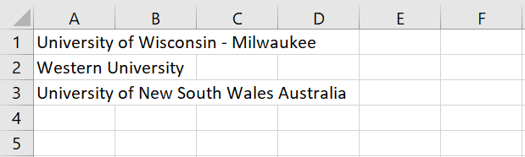

Recommendations:
- Start by adding the worksheet titled “Last”
- Then, you should activate the “United States” worksheet, select the bottom cell in the list, and copy it to the new worksheet
- Repeat this process for the next two worksheets
- End by activating the new worksheet
HINT: Look back to the “xlDown” trick from the lecture

Animals
For this assignment, I have listed some of my favorite animals as well as some data related to each of the animals. You will begin with cell A1 selected and run a code via VBA that will color the rows based on the Class of the animal. The color of the rows are as follows:
- Mammalia = RGB(50,155,60)
- Reptilia = RGB(240,140,30)
- Aves = RGB(55,220,250)
- Amphibia = RGB(240,10,215)
Please label your Sub as “Animals” for me. The completed file should look like this…

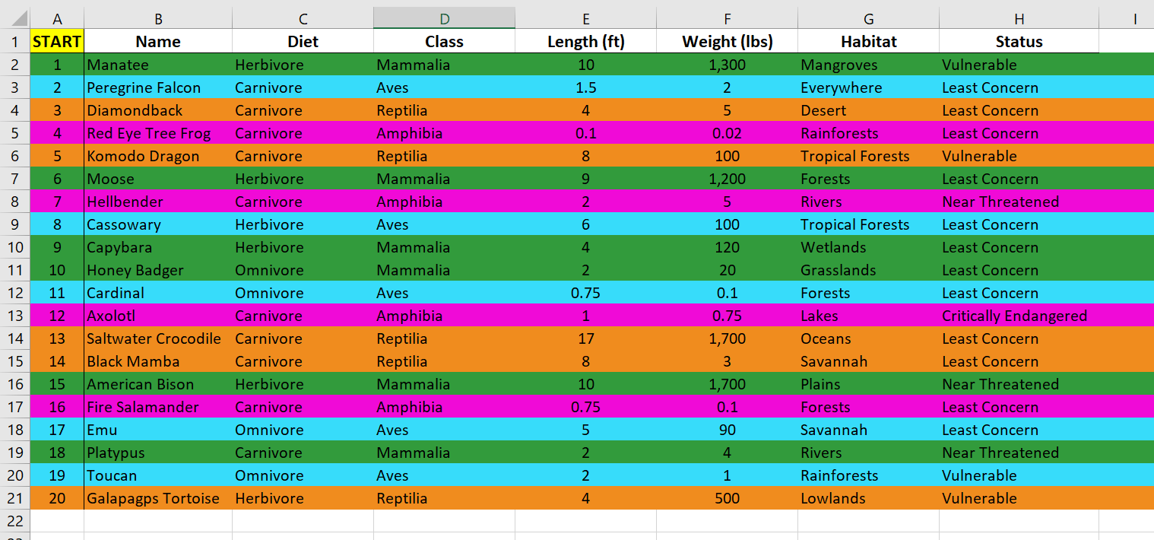
Recommendations:
- First, you will want to activate the cell that begins the range you will be working with
- Next, think of a way that you can cycle through each cell in the range you are working with
- Then, use a logical function to determine if the cell meets a certain criteria
- Finally, move on to the next cell in the range and so on and so forth
HINT: There is an object labeled “EntireRow” in VBA

